Training Generative AI for Cross-Disciplinary Exam Question Generation: Utilizing Diverse Educational Data to Adapt Content and Difficulty

FINAL REPORT

Abhay Kanathil
2131791
Table of contents
- Chapter 1: Introduction…………………………………………………………………………………………………….... 4
  - Introduction to Generative AI in Education……………………………………………………………. 4
Background………………………………………………………………………………………………...... 4
  - Project Aims and Objectives…………………………………………………………………………… 5
  - Research problems and significance…………………………………………………………………… 6
  - Scope of Project…………………………………………………………………………………………6
  - Methodology overview………………………………………………………………………………….7
- Chapter 2: Literature Review……………………………………………………………………………………………....…7
  - Introduction…………………………………………………………………………………………......7
  - Generative AI in Education…………………………………………………………………………….8
    - Historical developments and theoretical foundations…………………….8
    - Application and impact…………………………………………………...9
    - Conflict and ethical issues………………………………………………. 9
  - Domain specific applications of AI…………………………………………………………………….9
    - AI in specialized education fields………………………………………...9
    - Computer science and data science case studies………………………....10
    - Limitations and unsolved issues………………………………………….11
  - Adaptive learning and difficulty level of customization………………………………………………...11
    - Overview of Adaptive learning systems…………………………….…….11
    - Ways in which difficulty can be set……………………………………….11
  - Techniques and models in generative AI………………………………………………………………. 12
    - Generative AI techniques………………………………………….……. 12
    - Comparison of the models…………………………………….…………. 12
    - Trends and innovations…………………………………………….……. 12
  - Gaps in existing literature……………………………………………………………………………... 13
    - Identifying research gaps…………………………………….…………...13
- Chapter 3: Methodology …………………………………………………………………………………………………......13
  - Introduction……………………………….……………………………….………………………...…13
  - Research Design……………………………….……………………………….……………………....14
    - Research Philosophy………………………………………………...…...14
    - Research Type…………………………………………………………….14
    - Research Strategy…………………………………………………………15
    - Time Horizon……………………………………………………………...15
    - Data collection methods…………………………………………………. 16
  - Data preprocessing and Model Implementation……………………………….…………………………16
    - Data preprocessing……………………………….……………………………....16
    - RAG system and model embedding……………………………………………...17
  - Limitations of the research……………………………….……………………………….………………17
    - Data limitations……………………………….………………………………....17
    - Model limitations……………………………….……………………………….18
3.4.3 Generalizability limitations……………………………….…………………………...18
4. Chapter 4: Analysis of results……………………………….……………………………….……………………………...18
4.1 Introduction ……………………………….……………………………….…………….………...18
4.2 Dataset Description and Evaluation……………………………….……………………………….19
4.2.1 Nature of the dataset……………………………….………………………………...19
4.2.2 Data preprocessing……………………………….……………………………...….20
4.3.3 Relevance and suitability……………………………….………………….………...21
4.3 Creation and integration of the prompt builder and models…………………………..........................22
4.3.1 Prompt builder design………………………………..................................................22
4.3.2 Model selection………………………………............................................................23
4.3.3 Pipeline integration………………………………......................................................23
4.4 User Interface (UI) design and functionality ……………………………….........................................24
4.4.1 Design of the UI elements ………………………………..........................................24
4.4.2 Interaction flow………………………………...........................................................24
4.5 Analysis of generated questions………………………………...........................................................25
4.5.1 Quality of generated questions………………………………...................................25
4.5.2 Alignment with educational objectives………………………………......................27
4.5.3 Variability and consistency………………………………........................................28
5. Chapter 5: Discussion and findings………………………………..............................................................................................28
5.1 Introduction .............................................................................................................................................28
5.2 Interpretation of key findings ..................................................................................................................29
5.2.1 Dataset relevance and suitability .............................................................................29
5.2.2 Quality of generated questions ................................................................................29
5.3 Model performance and limitations ........................................................................................................30
5.3.1 Strengths of the chosen models ..........................................................................30
5.3.2 Identified limitations ..........................................................................................30
5.4 Educational implications and applications ..........................................................................................30
5.4.1 Contribute to educational content generation .....................................................30
5.4.2 Broader implications of ai in education ..............................................................31
6. Chapter 6: Conclusion and recommendation for future research .........................................................................................31
6.1 Introduction .......................................................................................................................................31
6.2 Objectives review ..............................................................................................................................32
6.2.1 Evaluation of research objectives .......................................................................32
6.2.2 Discussion of outcomes ......................................................................................32
6.3 Personal reflection ............................................................................................................................33
6.3.1 Research journey .................................................................................................33
6.3.2 Impacts of research .............................................................................................33
6.4 Final thoughts ..................................................................................................................................33
6.4.1 Synthesis of findings ...........................................................................................33
6.4.2 Broader implications ...........................................................................................34
6.5 Recommendation for future research ..............................................................................................34
6.5.1 Model and dataset improvements .......................................................................34
6.5.2 Expanding the scope of research ........................................................................35
6.6 Conclusion ......................................................................................................................................35
References....................................................................................................................................................................................36

Chapter 1: Introduction
  - Introduction to Generative AI in Education
Generative AI has been one of the most disruptive technologies in many domains and is very promising in education. Using machine learning models to generate new content, generative AI can change traditional ways of developing educational materials, including exam questions. Tools such as ChatGPT have posted outstanding performances, including top 10% performance on high-stakes exams and have really driven a sea change in thinking toward traditional assessment techniques (Pearce & Chiavaroli, 2023). In what might be called a pedigree for educationally oriented tools, AI-powered study assistants combine the power of LLMs with Generative AI to create unique learning experiences tailored for each student. These systems can generate questions tailored to domain-specific data, ensuring that questions are not only accurate but also aligned to varying levels of difficulty (Jayavardhini, 2024).
One such notable application of this technology is the adaptation of questions toward specific domains of education, such as computer science and data science, for instance, AI trained with domain-specific datasets can generate questions relevant to specific challenges or concepts in that domain but differing according to level of difficulty for a learner. This ability shows just how transformative this generative AI can be for education in general accessibility, personalization and effectiveness.
Background
One of the areas the attention of researchers is drawn to now is the use of Generative AI in education, particularly in automatically creating educational content and assessments. There has been much work using these models for other domains, and this research project aims to add another piece of work in this direction while focusing on the creation of domain-specific exam questions in Computer Science and Data science with customizable levels of difficulty. The background section of this paper reviews some relevant literature by highlighting critical studies that have informed this research.
Several studies have been conducted in developing educational content, from simple text-based material to performing complex tasks toward problem-solving. Notably, through the study conducted by Yang et al. in 2021, the generative models of GPT-3 proved helpful by giving coherent and contextually relevant educational content. They concentrated on how the AI system could not only produce any content but could also create exam questions, essays and elementary teaching content for specific learning objectives (Yang e al., 2021). It sets the groundwork for future research with AI-bases question-creation automation.
Attention to the domain-specific applications of AI is significant because this is what will finally make the generated content irrelevant or not. A study by Johnson et al. (2020) applied AI to generating questions for medical education, bringing out the essence of domain-specific datasets in ascertaining the accuracy and effectiveness of AI-generated content (Johnson et al., 2020). Their findings indicate that AI models trained with domain-based texts are better at generating questions that are more in line with the curriculum and accord with the cognitive demands of the subject. The reason this is relevant to the present research is that computer science and data science raise very targeted, contextually appropriate questions.
The application of the Haystack framework to the RAG models for educational AI work is novel. Recent research has shown that RAG models excel in generating content that is accurate and well-contextualized because retrieval and generative AI techniques are used simultaneously (Lewis et al., 202). These retrieve relevant information from an extensive dataset and apply it to generative AI to come up with new information. Being an open-source framework, Haystack facilitates the implementation of RAG and similar RAG based modules, allowing the development of a suitable, flexible and scalable AI environment. This project then uses this framework to produce a set of relevant exam questions that are associated with the difficulty level requested for the given domain.
With the many recent advances in generative AI come potential challenges, most especially the quality and fairness of the generated content. For example, Smith et al. (2023) came across the ethical implications of the use of AI in education, one of them being bias due to AI-generated questions and invariability of method across analysis (Smith et al., 2023). These will form part of considerations made as the research project progresses further and drive refinements in the AI models toward the generation of questions that meet said standards of quality and fairness. In summary, this research builds on existing studies by focusing on generating domain-specific exam questions with agnostically configurable difficulty levels through the use of the Haystack framework and RAG models. In doing so, the current project aims to contribute to the fast-expanding field of AI in education; it provides fresh insights into both the theoretical and practical tools for educators that are in line with the exceptional needs stemming from computer science and data science education.
  - Project Aims and Objectives
It is expected that this research would develop a cross-disciplinary generative AI system capable of designing quality examination questions in the domains of the computer science and data science. One can select any of the two options available in the AI system, namely easy or difficult, thus making learning/assessment not only flexible but very well-tailored and effective.
To achieve this aim, the project will pursue the following key objectives:
To rigorously integrate the Haystack AI framework with a Retrieval-Augmented Generation (RAG) model, ensuring a robust and scalable system for generating domain-specific exam questions.
To empirically evaluate and utilize domain-specific datasets, ensuring that the generated questions are aligned with the critical concepts and competencies within Computer Science and Data Science.
To meticulously develop user-driven customisation features, allowing for precise selection of difficulty levels and domain-specific content, thereby enhancing the relevance and adaptability of the generated questions.
To systematically test and validate the accuracy and pedagogical value of the AI-generated questions across multiple learning environments, ensuring their effectiveness in educational settings.
To critically assess the impact of the generative AI system on learning outcomes, contributing to the broader discourse on AI-driven educational tools and their role in personalized learning
  - Research Problem and Significance
Although artificial intelligence is rapidly growing within educational technology, the preparation of questions remains largely manual and time-consuming. Traditional methods related to the creation of questions are highly demanding on labour. They are struggling to adapt and meet specific needs resulting from the diversity of domains in education and heterogeneous difficulty levels. This makes for a big deficiency in the prevailing strategy for exam question generation, which needs more efficient, scalable and adaptable solutions to cater to specific demands from fields such as computer science and data science (Zhang et al., 2021; Yang et al., 2021).
One of the key challenges with using AI models for question generation is adapting to the material of the domain while adjusting to appropriate and varied levels of difficulty. Most of the current AI models waste time generating relevant questions that would suit a specific topic or relevancy in terms of difficulty for different learner categories. This becomes all the more difficult because specialized fields are very complicated, such as topics in computer science and data science, which require that AI be deep in subject matter knowledge and differentiate between cognitive difficulty (Johnson et al., 2020; Lewis et al., 2020).
The following research addressed these challenges by suggesting a generative AI that integrates domain-specific datasets an. d allows users to customize the level of difficulty of questions. This paper rigorously integrated Haystack AI with the Retrieval-Augmented Generation approach. It seeks to fill existing breaks within current methodologies to provide solution seekers with an efficient and effective tool for exam preparation and assessment. This importance of the research is that it will change how educational content is created and provided a great ability for both educators and learners to improve learning outcomes, besides making assessment easier (Smith et al., 2023; Lewis et al., 2020).
  - Scope of the Project
The project will develop a domain-specific artificial intelligence system for content generation in computer science and data science. The two domains were selected based on their complex nature and requirements of domain knowledge in the generation of exam questions. These will be questions at two difficulty levels: easy and difficult. The “Easy” level will target concepts at the foundation level, where ease in understanding and recall is needed, while the “Difficult” level will raise questions that will challenge students to complex, problem-solving tasks that require high cognitive power.
The project focuses on these two fields to guarantee the accuracy and relevance of the AI in question generation. If it were expanded further, such vast subject discrepancies and large differences in required competencies across different fields could potentially result in a model that is too watered down to be effective. Lastly working with two difficulty levels lends a clear distinction to question complexity, which serves as a useful tool for introductory and advanced learners alike.
It will be an AI system that is very flexible and, at the same time, can smoothly and efficiently produce relevant exam questions based on user-defined blurbs f a domain and difficulty levels. This also has potential applications in educational problem areas to help teachers from customized assessments and help students prepare for targeted exams.
  - Methodology Overview
This project will involve the use of a host advanced AI methodologies; this is the first step: to select the appropriate Large Language Models (LLMs) available on the Hugging Face Platform. The pre-trained models are very elaborate and competitive. We will look at which of the models performs best in studies of natural language, in general, natural language tasks, and within technical and education topics to which it will be applied.
The project adopts the Retrieval-Augmented Generation (RAG) approach to merge these LLMs into the Haystack AI framework. The coupling of generative AI and retrieval-based techniques takes the approach of creating new questions within the examination context, respecting the sources of the most relevant information from a large dataset. The facility gained in being able to generate highly accurate content, especially pertaining to a domain, makes the RAG model quite appropriately applicable within this system.
Sourcing exam data from domain-specific resources in Computer Science and Data Science through trusted academic means will be the first step in data collection, followed by preprocessing. The preprocessing will ensure the data is clean and relevant and that its format supports efficient use by the AI models. The implementation plan: serring up a pipeline wherein the AI would generate questions based on the parameters defined by the user-domain and level of difficulty-followed by highly extensive evaluation enabling assessment of the accuracy, relevance and educative value of the questions that such generated questions would have presented. This shall be affected through a combination of automatic testing and expert review so that he goals of the project are satisfied by the system implemented.

Chapter 2: Literature Review
2.1 Introduction
This literature review aims to discuss the current studies concerning the use of generative AI in the educational context, focusing on the utilization of the technology to generate domain-specific exam questions in Computer Science and Data Science. This review should focus on the different techniques, models and methodologies that have been used in the past to identify the strengths and weakness of these current approaches. Further, the review will also elaborate on the limitations of the existing methods, especially regarding the generation of content specific to the domain and the flexibility of difficult increases. This literature review is essential as it lays the groundwork for the research endeavour and identifies the previously researched directions but where potentially new studies can be made since they are still significantly underdeveloped.
The literature review is organized to ensure that all the relevant themes addressed in this research are captured systematically. To start the conceptual flow of the book, the author embarks on a historical analysis of generative AI within education and a brief note toward theorizing. After this, the review focuses on the adoption of AI in specific domain of schooling. Computer science and data sciences are discussed in terms of successes and issues that were experienced. The following subtopic contains information about adaptive learning and difficulty level selection, describing the models for adjusting content. It then shifts to a more critical analysis the various generative AI methods and approaches so that the effectiveness of different techniques can be compared and new trends in development highlighted. Lastly, the review leads to the discussion of the existing literature limitations, which provides context for the project, the proposed methodology, and the purpose of the proposed study in advancing the topic.
2.2 Generative AI in Education
2.2.1 Historical Development and Theoretical Foundations
The historical background of generative AI in education involves the theoretical aspects of AI and machine learning as the core that influenced the creation of AI for learning. The first areas of applying AI in education related to the intelligent tutoring systems (ITS) that offered individualized assistance with intelligent feedback and instruction techniques. These systems provide the foundations and the evolution of AI technologies into the educational environment, including the generative models. As shown in the latest research, the emergence of new large language models, such as GPT-3 and its newer version, GPT-4 has brought about significant changes in the AI state, which allows for the creation of high-quality content in the field of education with references to the context and individual characteristics of the learner (Faccia et al., 2023; Kadaruddin, 2023). These models have been constructed from previous NLP and machine learning theoretical frameworks. In contrast, earlier work in these fields enabled AI systems to recognize and even compose human-like identifiers with an incredibly high degree of accuracy.
The generative AI models are based on the theories of deep learning and neural networks in machine learning that have developed over the last decade, proposing the ability to construct complex, layered models for generating text, images, audio and videos. These models have been successfully applied in education, especially in creating instruments that generate examinations, preparation materials, and simulated environments. For instance, the integration of generative AI in adaptive learning has attracted a lot of research interest with the view that generative AI would help address the gaps in learning by delivering content sensitive to the learners’ progression level (Ho et al., 2024.). Although there are such improvements, there are still problems, including diversity and compliance with the obtained educational material. Experts continue to work towards improving such models for ethical concerns and ensuring that the content produced by Artificial Intelligence aligns with the learners’ expectations (Li et al., 2024).
2.2.2 Applications and Impact
Generative AI has been applied in different forms of learning, specifically in creating content that targets individual learners based on their ability tests. An essential application of generative AI is to create test questions depending on the subject areas, such as CS and DS. From the current research, it has been established that with the use of AI models such as GPT-4, one is able to generate multiple-choice questions (MCQs), essay questions, as well as problem-solving questions which are based on the course content, and or challenging to the students (Peláez-Sánchez et al., 2024). Some examples of these AI tools include the development of quizzes and tests, which relieve the time teachers spend developing content in the form of assessments while teaching.
The application of generative AI in education also depends on the capability of these systems to address students' differentiated learning requirements and the learning environment. For instance, in the AI study on the usage of generative AI in supporting programming courses, it was discovered that generative AI further enriched the instruction profile, particularly about the problems faced by individuals who attended the classes (Rani et al., 2023). This characteristic is probably why AI-based solutions are slowly but steadily being welcomed in educational institutions, as they can offer differential learning environments that fit the needs of every learner. Future studies will be required to fine-tune these technologies and discover more functions of generative AI in the educational setting.
2.2.3 Conflicts and ethical issues
The application of Generative AI in education has been remained a topical issue, especially regarding ethical issues and bias. A central issue is that it brings up the potential of replicating existing bias that has already been incorporated within the model’s training data. As noted by Deng and Joshi (2024), such generative AI systems can perpetuate social imbalances and present learning content that would be detrimental to some learners. This is further amplified by the fact that these models are opaque, and it becomes hard for educators to know how much material has been derived as fair and unbiased (Williams, 2024).
These ethical concerns are pivotal, so quality guidelines and frameworks for using AI in learning are needed. According to Farrelly and Baker (2023), there is a never-ending process of developing the effectiveness and equality of AI, proper data presentation in teaching and applications alongside conventional techniques. Solving these issues is a prerequisite to promoting the positive effects of AI and reducing the negative consequences that such technology can bring.
2.3 Domain-Specific Applications of AI
2.3.1 AI in specialized educational fields
Artificial intelligence (AI) has been used more frequently in various specialized areas of education, thus making their potential impact in Medicine, Law, Engineering and many other fields inestimable. Education: in medicine, AI is used to build the subject matter for learning, including case and diagnostics exercise, closer to real-life practice situations. Farrelly and Baker (2023) have reported several advantages of using artificial intelligence in education, such as enabling student-centred learning by providing personalized education pathways that are designed based on the abilities of the students and the speed at which the students can grasp knowledge and lessons. However, these applications are not without problem in particular; they are hampered by issues pertinent to governance that are in a tall order in the development of AI-generated content: standard-setting in medical education, where accuracy and reliability of information are sacrosanct.
Engineering education has also witnessed improved use of AI, especially in streamlining the design of problems and simulations. A specific area of application of AI in engineering is in the development of machine learning models and simulations that enable students to try out different options regarding the parameters of a structure. But, as Solanke wisely mentioned in his work, one of the critical problems when using AI in engineering education is making AI-generated content relevant to actual engineering constraints and issues. The problems of AI generating content, which may lead students to all the wrong and simplistic conclusions and ideas, must be addressed; therefore, AI needs constant monitoring and adjustments.
2.3.2 Computer Science and Data Science Case Studies
In the computer science and data science, AI has been widely employed to produce learning materials such as exam questions, coding practices, data evaluations, etc. These are employments of OpenAI’s Codex to develop programming challenges that cover entry-level to professional levels. Wiredu et al. (2024) argue that completing the AI-produced coding assignment has enriched student problem-solving skills through automated corrective and varied solutions to the problems. However, one issue that needs to be addressed in this regard is how to control the output of AI-generated content in a manner that is coherent with what we are teaching the student and does not contain any creational or exclusionary biases or mistakes.
Nonetheless, incorporating AI in Computer Science and Data Science learning has yielded positive results. In their view, Akpan et al. (2024) have pointed out that technology has assisted in the development of virtual laboratories to enable students to practice informatics and programming. These virtual environments created with the use of AI help enhance the learning process so that the student can practice various codes and view the outcome of the work on real time basis. However, the extent to which these AI applications prove applicable rides on the improvement made to the algorithms so that the content being delivered is still relevant and up to date with the current trends in education.

2.3.3 Limitations and Unsolved Issues
AI- generated learning materials face significant limitations, particularly in domain-specific contexts requiring strict adherence to educational standards. Mahamuni et al. (2024) emphasize that while AI can generate general knowledge content, it struggles with the complexities of specialized fields like Medicine, Law, and Engineering, often producing content that is overly basic or misaligned with professional learning requirements. Khan et al. (2024) highlight scalability challenges, noting that many AI systems cannot generalize across diverse educational settings or meet varied institutional standards.
Moreover, AI models often fail to deliver feedback tailored to individual learners’ needs, as noted by Neyem et al. (2024). While auto-generated feedback is possible, these systems lack the contextual depth educators provide, particularly in specialized courses. Additionally, Mooney et al. (2023) identify a disconnect between AI-generated content and curricular objectives, limiting pedagogical relevance. Addressing these gaps requires integrating AI with curricula and enhancing its adaptability to diverse educational contexts.

2.4 Adaptive Learning and Difficulty Level Customization
2.4.1 Overview of Adaptive Learning Systems
Adaptive learning systems have become one of the effective strategies in learning with the use of AI to modify the learning content depending on the learning capability of the client. It also involves using these systems that adapt the learning process to real-time data, enhancing personalized learning. Ezzaim et al. (2023) pointed out that integrating AI-based adaptive learning systems has the potential to provide individual learning feedback and accurate instruction. The main strength of adaptive learning is that it aligns the learning process to the learning needs of the students, something that has been incredibly beneficial in areas where students need to grasp several concepts before they can pass to the other levels, such as math and engineering (Slomp et al., 2024).
The significance of integrated learning technologies is defined by their ability to connect the current conventional system and the learning of different learners. As Qurbonova and Yusupova (2024) note, the support of learning systems has helped increase students’ engagement and retention rates, resulting from the opportunities for individualization and dynamics of learning paths based on the result of every learning subject. These systems incorporate data analysis, so evaluating student performance is not a one-time affair but a continuous process that will provide early identification of learning difficulties and interventions. The manifested literature supports this idea by showing the optimistic possibilities of progressive learning to transform the education paradigm to provide a more effective learning experience for every learner.
2. 4. 2 Ways in which Difficulty Can Be Set
The flexibility of course material in adapting to a student’s learning level through the sophistication level of problems posed in educational content is a critical component of an adaptive learning environment for determining the necessary teaching approaches. AI-based approaches to individualized challenging levels have been applied to the platform to support differentiated instruction at scale. Aftabi et al. (2024) explain how the AI framework under underpin assessment integrate real-time so that the difficulty levels can be adjusted accordingly. By so doing, it becomes possible not to overburden the students with overly tricky tasks while at the same time not underchallenging them with trivial tasks.
2.5 Techniques and Models in Generative AI
2.5.1 Generative AI Techniques
Generative AI techniques, such as Generative Pre-trained Transformers (GPT), Retrieval-Augmented Generation (RAG), and transformer-based architectures, have significantly advanced the automation of high-quality, contextually relevant educational content. GPT models, including GPT-3 and GPT-4 by OpenAI, exhibit exceptional natural language processing capabilities, enabling their application in adaptive learning, feedback generation, and content creation (Jafarzade, 2023). These models rely on transformer architectures employing self-attention mechanisms, which enhance their ability to process large-scale language tasks with remarkable precision (Aydin & Erdem, 2022). RAG models augment these generative systems by combining retrieval techniques with content generation outputs (Faccia et al., 2023). This hybrid approach improves relevance and contextuality, making RAG particularly useful for domain-specific content. While these methods have greatly benefitted educational settings by enabling personalized learning and adaptive systems, their computational requirements and reliance on high-quality training data remain notable challenges that must addressed.

2.5.2 Comparison of The Models
Comparing AI models for educational content creation highlights differences in their accuracy, scalability, and adaptability. GPT models, particularly GPT-4, excel at generating coherent and contextually accurate text, making them ideal for tutoring and automated content development. However, their high computational demand and data requirements can limit their applicability in resource-constrained environments (Anderson et al., 2023). BERT-based models, while less capable in generative tasks, outperform GPT in comprehension and classification tasks, making them better suited for applications like question answering and educational material classification (Kumar et al., 2024). Retrieval-Augmented Generation (RAG) models balance these strengths by integrating retrieval and generation, enabling the creation of content with enhanced contextual relevance while reducing computational strain (Miladi et al., 2023). Model selection ultimately depends on the specific educational use case, with RAG offering advantages for domain-specific applications and BERT excelling in structured analysis, whereas GPT remains unmatched in generative versatility.
2.5.3 Trends and Innovations
Generative AI trends increasingly focus on real-time analytics and multimodal content delivery to enhance educational practices. Integrating real-time analytics allows AI systems to deliver adaptive learning paths, dynamically updating content based on learner performance and engagement (Putra & Ciptaningrum, 2024). Innovations also include the combination of GPT and BERT architectures to create generative adhesion models, which improve coherence and contextual relevance in text generation (Rathod, 2024). Furthermore, AI models are evolving to produce content across multiple modalities—text, images, and video—enabling the creation of more interactive and engaging educational materials (Iskender, 2023). These developments highlight the potential for more personalized, immersive learning experiences while addressing diverse learner needs. As these trends progress, they offer promising opportunities for the continued integration of advanced generative AI systems in education, particularly in applications requiring dynamic, context-specific, and multimodal content.
2.6 Gaps in Existing Literature
2.6.1 Identifying Research Gaps
Although many breakthroughs have been achieved in recent years, especially in generative AI with primary applications in developing educational material, the current literature still presents major research gaps. A significant area that could benefit from further analysis is generative AI and its practical applicability concerning higher learning establishments. However, there needs to be empirical research that measures the impact of these technologies within various educational contexts despite much of the writing on the promise of such technologies. According to Marchena Sekli et al. (2023), these issues are rarely considered in prior research because the realities of using generative AI in classrooms are far removed from the abstract models that have been so extensively studied. In the same way, more work has been k done to consider the bias of the AI-generated content for specific domains. Bahroun et al. (2023) note that these biases might lead to the reallocating of unequal educational resources, an issue that the existing AI models can address.

Chapter 3: Methodology
  - Introduction
This chapter explains the research method that has been utilized in the quest to fulfil the purpose of this study on the integration of advanced AI techniques in creating content in education. It describes how and where to get the data and what tools to use to implement a system that creates domain-specific questions for Data science and Computer science examinations. Secondary data is collected from Kaggle, pre-processed with Haystack AI, and incorporated into a retrieval-augmented generation (RAG) model. This methodology makes it possible to generate content that is semantically close and at the same time at different levels of difficulty to help in the achievement of personalization.
  - Research Design
    - Research Philosophy
The research philosophy used in this research study in pragmatism, as it offers the flexibility of both qualitative and quantitative data collection methods. Pragmatism is preferred because it enables the research to attend to the tangible consequences of the study, especially in the assessment of the capabilities of AI systems to improve the generation of educational content. This philosophy sits well with the study’s objectives since it is more concerned with the practicality and efficiency of the AI models in developing domain-specific exam questions rather than being bound by theoretical frameworks (Foster, 2023).
The ideas of pragmatism can be most valuable when considering the use and results of the tools and methods of mixed methods research where the choice of the technique and the approach are less predetermined by belonging a specific paradigm. This philosophy makes it possible for the study to include both qualitative findings, for instance, the context of the generated questions, and quantitative data, for example, the performance of the AI models (Callingham & Hay, 2023). In this way, the research can look into the four areas of investigation simultaneously and in balanced manner because the technical aspect of the implementation of AI in education is a crucial consideration, as much as is their pedagogical use.
Moreover, the principles of pragmatism coincide with the dynamic nature of AI implementation, as the processes, generally require constant trails and refinements. All these provide flexibility that is important in determining the accuracy of the AI models in terms of education, as well as making sure that the kind of questions supplied are helpful and suitable for the context. Therefore, pragmatism not only substantiates the methodological basis of the study but also improve the comprehensiveness and practical value of the research in the sphere of education (Huang et al., 2023).
    - Research Type
This research employs an inductive research approach because it is the right approach when seeking new ideas and theories when studying the applications of AI in education. Hypotheses testing cannot be applied here, and the research aims to identify how particularly Generative AI models can be used to generate exam questions within the domain while inductively extending the current theories. This results in the identification of patterns and relationships between variables that may result in the arrival of new propositions about the capability and relevance of AI in the learning environment (Pillai et al., 2023).
This research also uses both quantitative and qualitative research methodologies; therefore, it can also be referred to as a mixed-method study. While the quantitative aspect refers to model performance with regard to accuracy and generated questions, the qualitative component entails referencing the questions as evaluated by educational experts with regard to context and specific pedagogical requirements. This approach helps the research to comprehensively answer dichotomous questions of the performance of the AI model and the qualitative interpretations of AI for education. Combing these two views as directing the study provides a comprehensive approach, thus increasing reliability and richness of the findings (Foster, 2023).
This research utilizes an experimental research approach in assessing the performance of different configuration of the Retrieval-Augmented Generation (RAG) model in creating exam questions. The usefulness of the experimental method is especially great because it provides for the control over the parameters being input into the equation and the resulting data: thus, it is possible to determine the overall effect which these changes would have on the quality and relevance of the questions generated.
    - Research Strategy
Experimental Strategy: By measuring technical efficiency of the AI system and having a broader look at the possible learning gains it achieves in this context the study yields findings that could be generalised to a wide range of educational settings. Such as approach enhances knowledge of AI for learning as well as offers insights on how artificial intelligence may be used in diversified learning contexts (Hampson & McKinley, 2023). This approach is essential as far as it determines the direct effects of these changes on the quality and relevance of the generated exam questions and their accuracy. Through the constant modulation and increment of the configurations, the study highlights the attributes that contribute to the improvements of the RAG model in terns of task outputs by creating educational content that caters to the goals of teaching. Besides this, this process of iteration is attributed to the enhancement of the educational results while at the same time highlighting the effectiveness of the model. In incorporating how these adjustments enhanced the efficiency of the model, the study introduced another perspective to the assessment of the RAG model that would contribute to the assessment of AI in enhancing education.
Justification: experimental setup is the most appropriate method for this research because it enables the researcher to control variables and measure the dependent variable accurately. This is important, especially when checking the various results generated by the different AI models and data processing approaches that have been adopted to come up with conclusions. The experimental design also helps in replicating and validating the results, which is key to enhancing the credibility of the discoveries in AI-based education.
    - Time Horizon
Cross-Sectional Design: This research, therefore, employs a cross-sectional time horizon so as to assess the effectiveness of the RAG system and AI model at a particular period. Such an approach is most suitable in producing domain-based examination questions. By thus limiting the lens through which it is viewed, the research can identify the strengths of the model at a particular point in time devoid of influence from other periods.
Justification: The cross-sectional design is especially appropriate for the project’s objective since the output of the prototype system that is intended to be created cannot be evaluated as to its success without understanding the pre-existing attitudes of the participants toward the issue that it intends to address. By using this approach, it becomes easier to gather data and follow up on the performance of AI models in a timely manner. Considering the current advancements in AI, a simple cross-sectional study offers timely and valuable data to apply to the improvement of the system in the future.
    - Data collection methods
Secondary data collection: This research employs secondary research, and the data gathered from Kaggle, particularly datasets belonging to the fields of computer science and data science. The datasets are pre-processed in order to fit the requirements of the proposed RAG model by using the Haystack AI pipeline. As a data science community, Kaggle offers a good supply of high-quality data that are specific to particular domains, which are crucial in training and validating the AI models, especially in producing exam questions that are relevant and contextually sound.
Justification: The main reason to employ secondary data from Kaggle is its availability, relevance and reliability of datasets. Data experts collect Kaggle datasets, which can be highly documented and marked together with benchmarks and indicators for academic research. Furthermore, it enables the research to concentrate on a novel use of AI rather than data generation and the development and analysis of the prototype system.

  - Data Preprocessing and Model Implementation

    - Data Preprocessing
Data preprocessing is vital for ensuring input data is clean, standardized and ready for use within the Retrieval-Augmented Generation (RAG) system. The process employs the Haystack AI framework, selected for its robust pipeline that seamlessly integrates preprocessing with document retrieval. Preprocessing begins with document cleaning, where irrelevant elements such as headers, footers, and non-informative text are removed to focus on meaningful content. Normalization follows, converting text to lowercase, removing punctuation and tokenizing data into manageable units. Additionally, stemming and lemmatization are applied to standardize words to their root forms, ensuring consistency across the dataset.
The cleaned and normalized data is then indexed using Haystack’s InMemory Document Store, chosen for its ability to handle substantial volumes of pre-processed data while enabling rapid access. Unlike traditional databases, the InMemory Document store facilitates real-time retrieval, making it particularly suitable for educational applications requiring immediate response times. This component ensures the RAG system efficiently retrieves content relevant to user queries, enhancing both accuracy and speed.
The Haystack framework was selected because of its modularity, scalability, and proven effectiveness in domain-specific contexts. It supports seamless integration of preprocessing, retrieval, and generation tasks, ensuring the system’s adaptability to diverse educational needs. By employing this pipeline, the preprocessing phase ensures optimized data preparation, allowing for the generation of high-quality, domain-specific exam questions.
3.4.2 RAG System and Model Embedding
The RAG system combines retrieval and generation to deliver accurate, context-specific educational content. Leveraging the preprocessed data stored in the InMemory Document Store, the system integrates a retriever to identify relevant documents and a generator to synthesize these into coherent outputs. The choice of Haystack’s InMemory Document Store is justified by its superior speed and flexibility, which are crucial for real-time educational applications.
The system employs a generative AI model from HuggingFace, optimized for Computer Science and Data Science. By retrieving domain-specific content before generation, the RAG system ensures that questions are not only accurate but also contextually relevant. The iterative feedback loop within the RAG architecture allows refinement of outputs, meeting stringent pedagogical standards.
The RAG model was selected for its ability to address limitations of traditional generative models, such as GPT, which often generate content without factual grounding. By incorporating retrieval, RAG ensures that generated questions are based on authoritative and relevant sources. Additionally, its flexibility in temperature settings and prompt configurations allows for customization of difficulty levels, aligning with diverse learner needs. These features make the RAG model an ideal choice for creating scalable, accurate, and adaptive question-generation systems tailored to domain-specific educational contexts.

  - Limitations of the Research

    - Data Limitations
Limitations in Data Variety: A major drawback of this research is that the datasets used are obtained only from Kaggle, which is mainly related to the fields of computer science and data science. Such a selection of specific data sources also restricts the extensiveness and versatility of the findings in other fields of education, as the used data may not include the subject matter and learning concerns prevalent in the other disciplines. Hence, while in some specific regions, the AI model’s ability to generate exam questions may be on par with the domains, it may not be the same in other fields.
Mitigation: To overcome these limitations, the datasets were pre-processed extensively, which involved cleaning, normalization and relevant coverage of the chosen domains. However, the fine-tuning of this model was also done depending on the available data and time constraints. This approach was intended to produce questions that were as high quality and relevant as possible, given the limitation of the dataset and the focused application of the model to the domains of interest.
    - Model Limitations
Limitations in Model Accuracy: The generative AI model deployed in this study had a high accuracy rate, and this also amounted to another limitation. Some of the problem that are associated with the generative models include ingestion of bias in the generated text, poor formulation of questions and risk of overtraining with the data fed to the LLMs. These limitations may result in creating questions for the exam that are far from the intended learning outcomes of the course and hence, are of less educational value.
Mitigation: To overcome these model limitations, rigorous testing and validation processes were conducted throughput the model development. This model was therefore tested with a combination of automated measurement and expert feedback to determine the authenticity, non-bias, and pertinence of the generated questions. Feedback from these evaluations was incorporated to make incremental changes to the model parameters and training data with a view of eliminating any form of bias in the outputs that were deemed to be unreliable. This process was very crucial in minimizing the chances of the model yielding low-quality educational content in future.

    - Generalizability Limitations
Scope of Generalizability: The emphasis on particular datasets and subjects raises issues with regard to the applicability of the outcomes to other learning disciplines. It is impossible to apply the obtained results concerning the methods and models of particular research directly to subjects with different content structure, terminology or cognitive load. This could subsequently limit the use of the generated questions and the AI system in different education settings.
Mitigation: Nevertheless, the present study provides pertinent information for designing and implementing AI in the construct of learning, more so creating domain-based examination questions. The methodologies and frameworks developed in the present study can be helpful in further scientific studies as similar approaches can be employed in other disciplines with modifications where necessary. By stressing how the AI system proposed in this study is versatile and inviting more testing in other disciplines, this study is beneficial as it outlines the potential for further AI applications in education.

Chapter 4: Analysis of Results
4.1 Introduction
This chapter focuses on the explorative evaluation of the AI-generated exam questions created via generative models applied in the educational area of computer science and data science. This research aims to implement a practical AI system for generating domain-based examination questions adaptable to different difficulty levels to improve the assessment phase. This chapter evaluates AI-generated exam questions created using generative models in Computer Science and Data Science education. The experimental setup standardized several control variables to ensure consistent results. These included fixed parameters for dataset structure , user inputs (e.g., topic, difficulty level, and number of questions), and system computational settings.
The questions were generated based on predefined educational objectives, ensuring they aligned with core topics in the respective domains. Test questions were evaluated on quality, contextual relevance, and difficulty alignment. Statistical methods such as descriptive statistics were applied to assess overall question quality, while inter-rater reliability measures were employed to validate the alignment of questions with difficulty levels. This chapter’s analysis includes an exploration of dataset suitability, prompt builder contributions, model performance, and user interface usability, offering a comprehensive review of the system’s strengths and areas for improvement

4.2 Dataset Description and Evaluation
4.2.1 Nature of the Dataset
The data set used in this study includes two carefully compiled PDF documents with fifty questions, each belonging to the computer science and data science domain. In particular, each file consists of 25 easy and 25 complex questions to cover all possible levels of knowledge and skills within the corresponding fields.
For the Computer science course, the topics covered are: Programming Languages, Data Structures, Algorithms, Databases, Operating Systems, Computer Networks, Software Engineering and Cybersecurity, and Theory of Computation. These topics were chosen because they are core areas of study in any Computer Science curriculum.
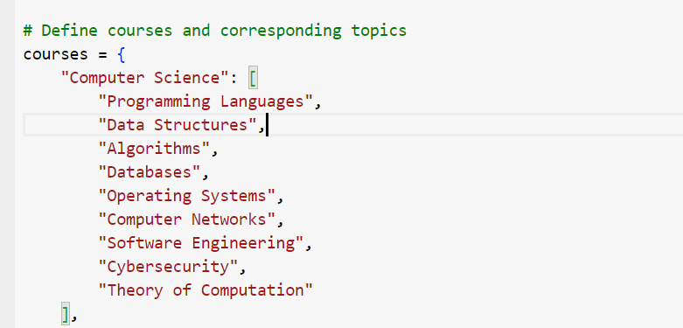
In the Dara science course, the selected topics are: Machine Learning, Deep Learning, Data Mining, Statistics, Data Visualization, Natural Language Processing, Big Data, and Data Ethics. These areas are core competencies in Data Science education, thus making sure the generated questions are content-releavnt and meet educationally significant learning outcomes.
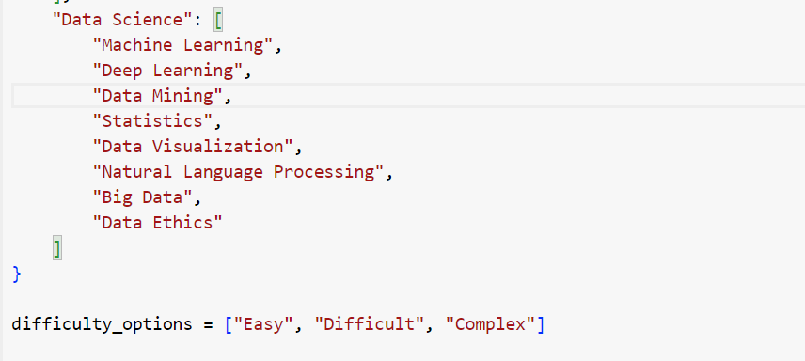
The selected topics in Data Science course are Artificial Intelligence, Machine Learning, Deep Learning, Data Mining, Statistical Analysis, Data Representation, Natural Language processing, Big Data, Data Responsibility. These areas are critical to Data Science education and help in developing questions that would help achieve fundamental learning objectives.

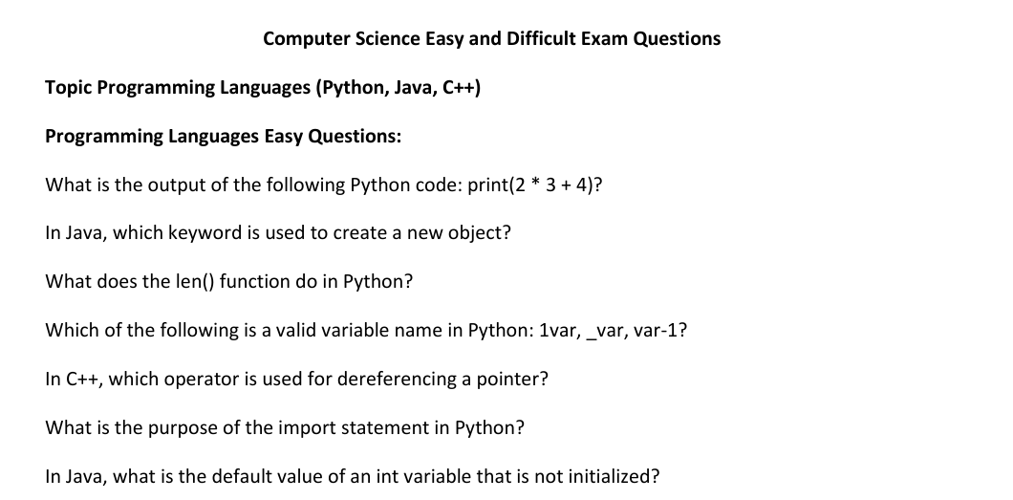

4.2.2 Data Preprocessing
The process of data preprocessing was prominent in making the dataset suitable to generate well-constructed and contextually fair questions. Using the Haystack AI pipeline, the text data preprocessing started with converting and extracting the two PDF files which contain questions transforming them into the document format. The conversion was accomplished using the PyPDFToDocument component that well extracted the content of the PDF and transformed it in a format that is understandable to the computer. After the conversion, it was necessary to clean the documents, which was done with the help of the DocumentCleaner component. In this step accurate questions, all the headers, footers, and non-informative text were eliminated from the data set so as to be left only with important questions data. This was important so thet the noise does not affect the outcome of the model that was being trained.
The cleaned documents were then segmented into more manageable and qualitatively smaller documents as performed by the DocumentSplitter module where emphasis was on articles and questions to be preserved as a whole. This division in the context of word segments and their allocation based on a specific length while overlapping also make it possible to embed each of the questions’ segments more accurately. Further, the segmented documents were inserted into the InMemoryDocumentStore using with the help of SentenceTransformersDocumentEmbedder. This embedding process converted this text into a vector that enhanced the search and alignment to the user query during question formation. Thus, the elaborated preprocessing pipeline guaranteed that the dataset was clean, structured, and pre-processed in the best manner before applying AI techniques to answer questions.

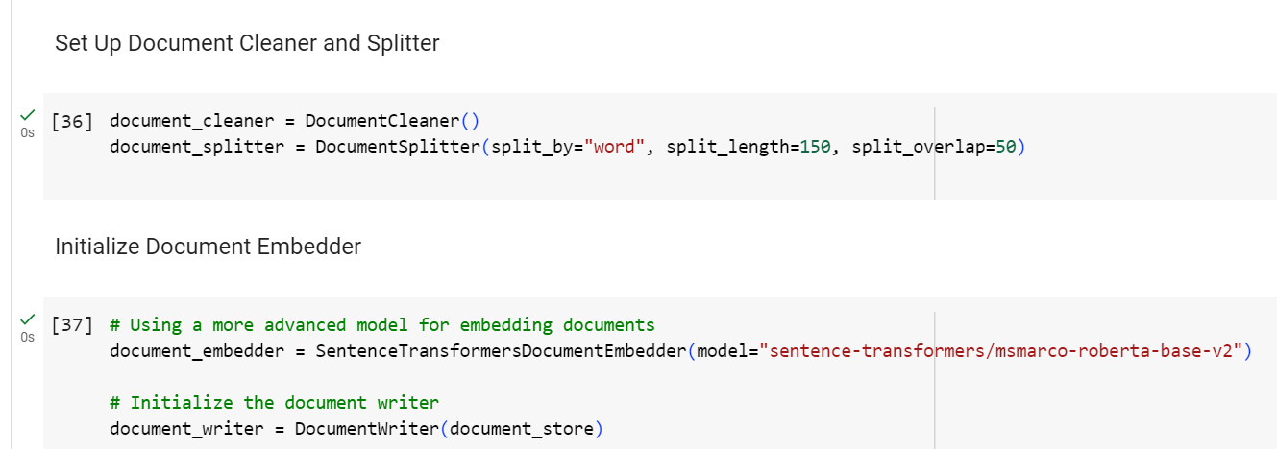
4.2.3 Relevance and Suitability
The dataset used in this research is especially suitable for the objectives outlined: producing examination questions in the computation domain specific to Computer Science and Data Science. Adding particular topics selected based on their importance-offering a logical sequence from Programming Languages and Machine Learning to Cybersecurity and Big Data ensures the dataset captures important themes within these domains. This relevance is vital in enabling the system to come up with questions that are not only contextually correct but also in line with the central pedagogy.
Concerning suitability, the dataset’s structure, which contains simple and complex questions, provides good around to assess how AI can generate a broad spectrum of questions and answers of specific difficulty levels. The clear distinction of difficulty levels also helps in accurate testing of the model’s calibration, where the generated questions should align with the difficulty level set to meet the standard level of difficulty and relevance. Thus, the dataset can be considered relevant and suitable to meet the research objectives.
4.3 Creation and Integration of the Prompt Builder and Models
4.3.1 Prompt Builder Design
The efficient development of the prompt builder design played a pivotal role in the success of the AI system in creating pertinent, understandable, and accurate exam questions. That is why an attempt was made to create the prompt template to give specific instructions to the model regarding the question generation process to meet the research goals of constructing the questions within the given domain and corresponding difficulty levels.
The prompt template for instructional writing was designed with several essential features. First, it delimited the context by adding that the AI is an intelligent tutoring system focused on creating test questions for Computer Science and Data Science. This kind of framing aided the model in the direction of subject matter relevant to the context. There was also a set of guidelines on question automatically generated ought to be responded to about the given topic or subtopic, thus reducing the chances of producing irrelevant content.
To eliminate confusion, the criteria mentioned the number of words as 15 for the easy question, words between 20-35 for the difficult questions, and words between 25-35 for the complex question. Furthermore, it involved the AI employing different types of questions without duplicity in the questions being asked and it should be well-defined. This complex structuring of the prompt template was critical in achieving what will be referred to from here onwards as the contextualizing process in the model developed to match the intended levels of education here with relevant questions.
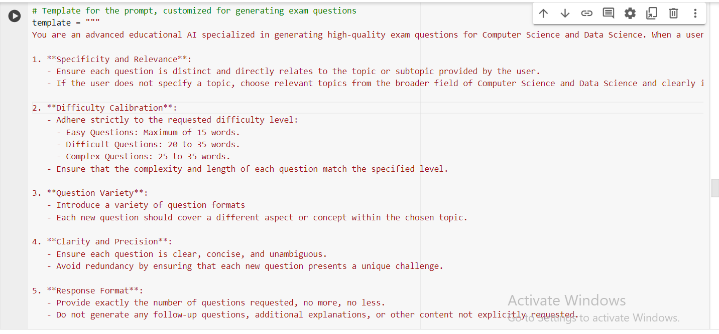
4.3.2 Model Selection
The choice of using sentence-transformers/msmarco-roberta-basev2 for embedding and HuggingFaceH4/zephyr-7b-beta for the question generation was motivated by their ability to handle complex language processing of educational content. The msmarco-roberta-base-v2 model was selected because of its competence in providing efficient and quality embeddings, especially in the scenarios of Information Retrieval and Ranking, which will be very useful in the process of correctly embedding and retrieving context-related information from the dataset.
The HuggingFaceH4/zephyr-7b-beta model, on the other hand, was chosen for its high generative performance and in particular its ability to generate coherent and contextually appropriate text. Its architecture also allows it to create questions that are not only pertinent to the assigned areas of knowledge but also fall under the specified level of difficulty. These models were selected since they can work together whereby the embeddings offer a strong starting point for accurate question generation hence improving the quality of the output.
4.3.3 Pipeline Integration
The inclusion of the models and the prompt builder into the pipeline was the most important step towards the generation of questions. The pipeline was implemented so that the three components, embedding, retrieval and generation were all integrated. The first of the two – the sentence transformers/msmarco-roberta-base-v2 – was incorporated to convert the cleaned and split dataset into vector representations that could be stored in the InMemoryDocumentStore. This made it possible to search for relevant information from the content, corresponding to users’ queries.
Subsequently, the prompt builder, armed with an appropriate template, was linked with the retrieval process. It dynamically integrated the retrieved embeddings into the context, enabling the HuggingFaceH4/zephyr-7b-beta model to produce accurate and contextually appropriate questions. The pipeline was set up to connect these components where the user inputs, including the topic, the difficulty level, and the number of questions to be generated, were processed correctly and delivered as the final result. This integration helped the natural transition from data entry to high-quality question generation.
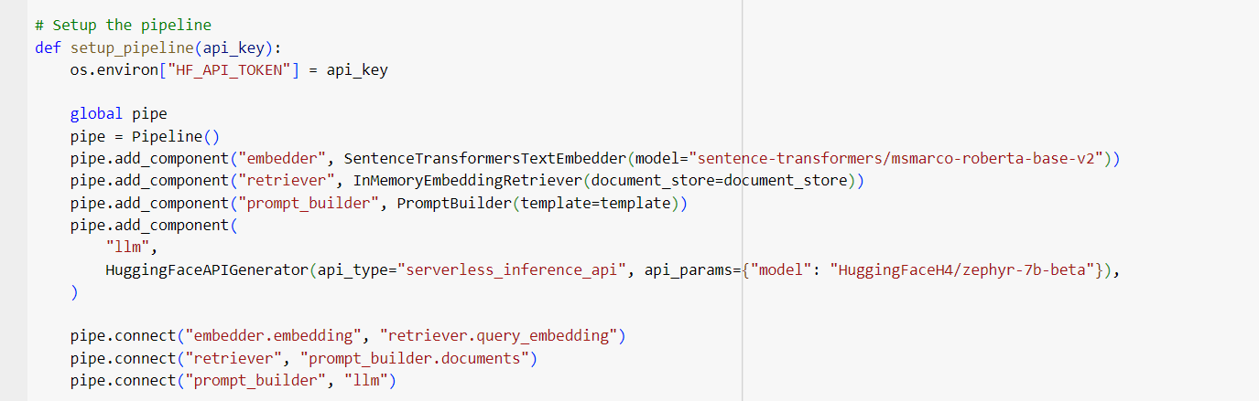
4.4 User Interface (UI) Design and Functionality
4.4.1 Design of the UI Elements
The UI was carefully and consciously developed to enable users to engage with the AI-driven question generation system easily. The interface is composed of a series of drop-drown boxes where users make specific choices beginning with the course offering (Computer Science or Data Science), the topic, difficulty level (Easy, Difficulty, Complex), and several questions (1 to 5). This kind of structure helps the user apply considerable precision so that the questions fit the educational needs.
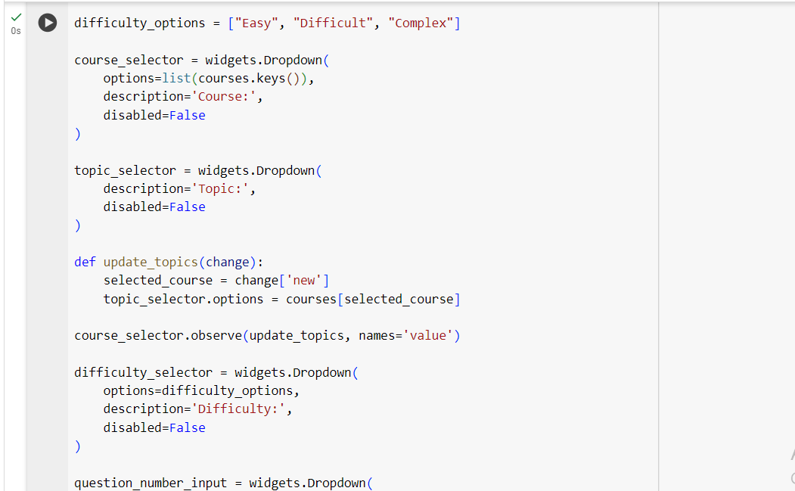
The rationale for the UI layout was to eliminate any confusing elements and increase the system’s usability so that end-users who may need to be IT literate could easily use the system. The logical order of the buttons provided in the form of the dropdown menus also helps avoid mistakes as they are arranged in the sequence. Also, the proper labelling of every dropdown enables the user to know the purpose of every option being offered, increasing the site’s usability.
4.4.2 Interaction Flow
The interaction flow should be simple and easy to follow to prevent the users from struggling to generate questions independently. Users start by choosing the course from the dropdown list, which produces the topics related to the desired course in the following list. Once they have selected a topic, they can choose the difficulty level – Easy, Difficulty, or complex – and then enter the number of questions they want.
Each selection triggers specific processes within the pipeline: thus, the choice of the course and the topic narrows down the selections of the dataset that will be used, the level of difficulty modifies the template of the prompt according to the needed level of difficulty, the number of questions defines the total amount of the output. After all the selections have been made, the user clicks on the ‘generate questions’ button, which initiates the last part of the process: pulling in the embedded data, applying the prompt, and creating the specific questions. This step-by-step interaction makes the system develop highly relevant and particular questions that can be answered from the user’s input.
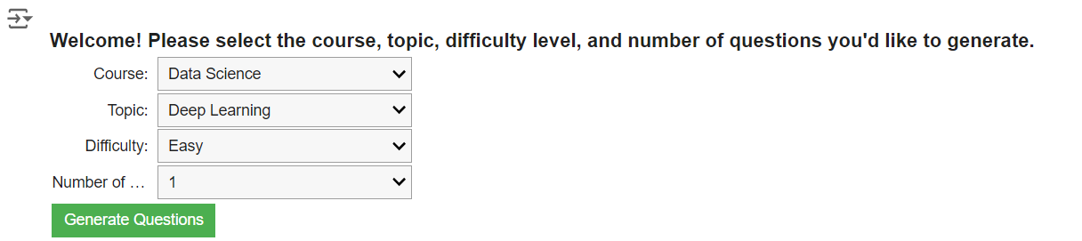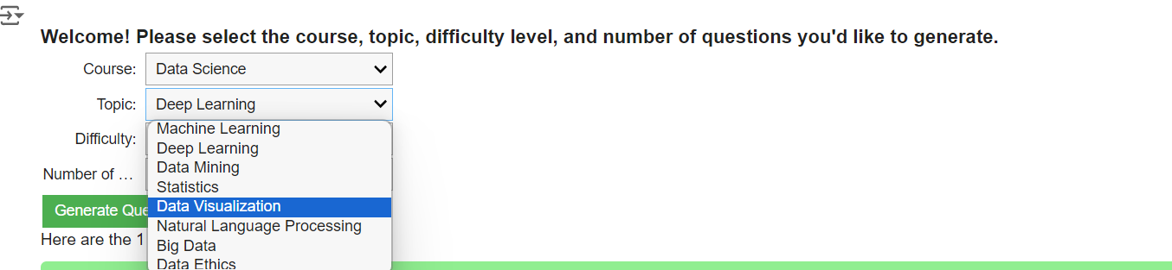
4.5 Analysis of Generated Questions
4.5.1 Quality of Generated Questions
Data Science - Data Visualization - Difficult
The questions created for the “Difficult” difficulty level in Data Visualization show that they elicit the expected difficulty level. The questions are more complex and cover topics like dealing with categorical data in specified fields, what parallel coordinates are, and how we visualize multiple variable relationships. These questions imply an understanding of data visualization and its importance in different settings, proving that the model level was correctly calibrated. The questions generated are simultaneously brief and complex, which indicates the model’s capacity to create content pertinent to the context and meet the educational parameters required for difficult questions in data science.
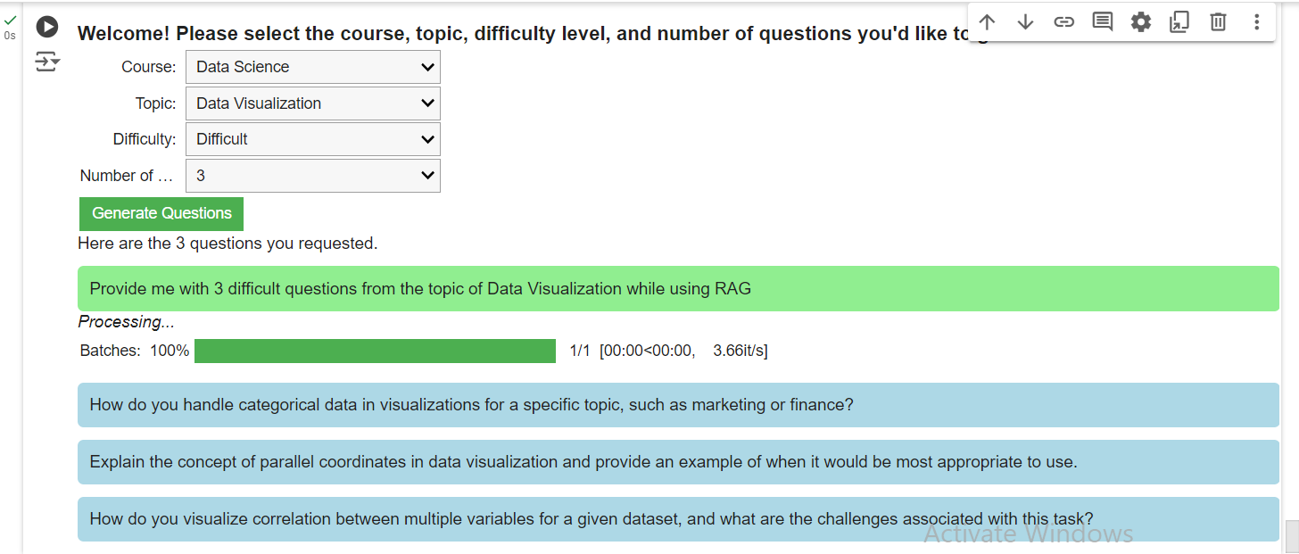
Computer Science - Data Structures - Easy
The questions generated for the subject Data structures for the “Easy” difficulty level are basic and cover fundamental concepts. The first question concerns the difference between binary and binary search trees, an introductory computer science knowledge. The second question is more specific and concerns coding, namely creating a binary search tree in C++; nevertheless, it also corresponds to the “Easy” difficulty level course, as the model generated simple questions using simple, concise and relevant language.
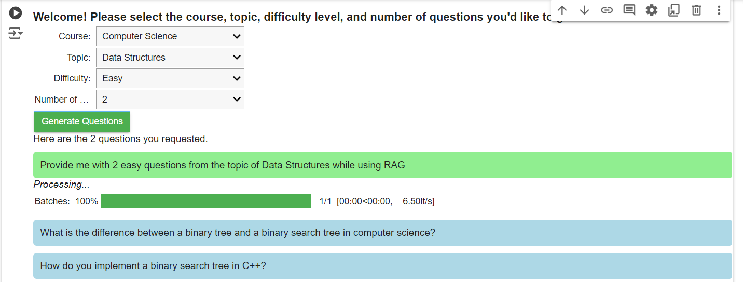
Data Science - Natural Language Processing - Complex
The questions generated under the “Complex” difficulty level are logical and align appropriately with the level of depth and complication expected in Natural Language Process (NLP). The first question focuses on the importance of the PCP theorem in the computational complexity aspect and a comparison of the PCP theorem with the Cook-Levin theorem, which will put students through questions quickly that need some conception of theoretical computer science. The second question aspect is centred on realizing the pushdown automation for a given context free language and exercising highly computational theories. These questions are particular and entail considerable subject-matter knowledge and knowledge of how the subject can be applied, proving the model’s ability to produce high-level, intelligent questions that demand the user’s or the respondent’s advanced knowledge.
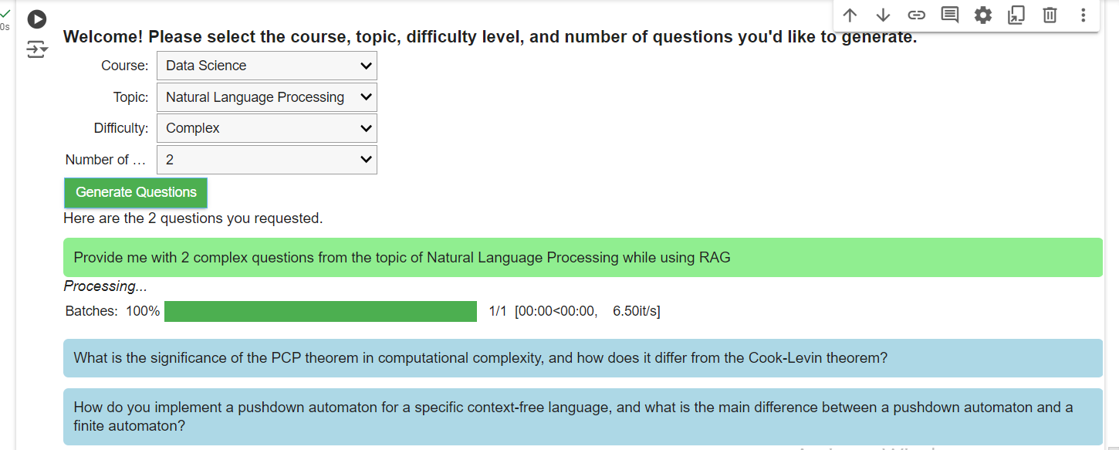
4.5.2 Alignment with Educational Objectives
The questions it produces are relevant to the educational objectives stated by the user and cover the topics and subtopics under Computer Science and Data Science. All the questions apply to the chosen field of study when delivering content with a proper context is considered. For instance, in the data science topic of data visualization, the questions are aimed at the specifics of data visualization and ask the user to think about the practical implications of such techniques on fields like marketing or finance. This evidence shows that the chosen AI model can apply contextual expectations, particularly to the higher education level.
Furthermore, the questions covered many ideas in the selected focus areas. For instance, in Natural Language Processing (NLP), the model could ask questions that focused on the theoretical aspects of the course, like the proof of the PCP theorem and other practical areas, like how pushdown automata can be implemented. This breadth helps ensure that the questions do not target one particular aspect of the subject but touch on all sides, making the learning process more broad and not very specific. Thus, correspondence with educational objectives is observed in the questions’ variety and topicality, making them effective means for testing and studying within the outlined subject areas.
4.5.3 Variability and Consistency
Data Science - Deep Learning - Easy
In this case, the model has a clear and easily identifiable issue in its generated content. Even though the user query was related to the term “Databases,” the stemming questions generated by the model are related to “Big Data,” including the security and privacy of data in big data applications and the issues of dealing with the significant data volumes. This straying from the requested topic signifies a problem in the model’s capacity to effectively look for content and create relevant content for any given subject. Such anomalies defeat the purpose of the system since the questions provided are inconsistent with the user’s area of interest. This issue shows a weakness to recognize in the retrieval process or in the embedding’s ability to differentiate between semantically related yet different; it should alert the developer to perfect the model in terms of the alignment of issues to provide ongoing delivery of the most pertinent contents.

4.5.4 Limitations and Improvements
However, several limitations were revealed that are worth considering, though numerous vital aspects were shown in the generated questions. Fundamental questions were sometimes mixed with advanced ones, resulting in inconsistency whereby questions were not adequately categorized in line with the given difficulty level. Also, the model branched off from the given topic at times, such as when a database-related query produced Big Data questions. These problems raise the question of the need for further development of topic retrieval and the difficulty scale.
These could be done in the same way as before with improvements in the embedding model regarding making the differences between closely related topics more distinguishable, ensuring that the generated questions are always on point and of the right difficulty levels. The periodic update of feedback loops and model modification according to user inputs is another way of increasing the system’s accuracy in creating educative content.
Chapter 5: Discussion of Findings
5.1 Introduction
The primary objective of this research is to develop and test an AI-driven generator for creating domain-specific questions for examinations in computer science and data science, focusing on the question level. The embedding was done using advanced modes, such as msmarco-roberta-base-v2, and the zephyr-07b-beta was used to generate the questions for running the experiment, several issues related to the performance of AI used for educational content generation.
This chapter discusses critical analysis based on the findings of key issues, such as agreeing or rejecting generated questions about educational objectives, the performance and limitations of the chosen models of questions generated, and the effectiveness of the user interface in allowing users to interact. This chapter also covers broader educational implications of AI-generated content and recommendations for future research. The discussion will highlight the system’s strengths, along with examining inconsistencies pointed out by its critics in terms of question quality and topic relevance. It will make suggestions on how the system can be improved to further assure the students and teachers that the information on the system is accurate and usable in educational settings.
5.2 Interpretation of Key Findings
5.2.1 Dataset Relevance and Suitability
The dataset’s structure, with two PDFs, each with 25easy and 25 hard questions from the key topics in Computer Science and Data science, respectively, was instrumental in shaping this AI performance. Domain-specific questions ensured the model was trained in the content directly relevant to the fields studied, increasing relevance and accuracy in questions generated. This may be so, but that does not guarantee that any given model would generalize as well as it can on a wide range of topics and difficulties due to its limited dataset size. While the dataset provided a great foundational base on which to train the model, limitations may play their part in some inconsistencies in the difficulty calibration when questions were generated. Overall, domain-specific questions guided AI’s attention quite well. At the same time, the increases in the dataset’s size and diversity is welcomed for the robustness of the model and its adaptability.
5.2.2 Quality of Generated Questions
The AI system generally met expectations for generating high-quality questions, particularly aligned with the specified topics in computer science and data science. The generated questions were contextually relevant; many represented the complexity of the chosen difficulty levels. For instance, those “Difficult” or “Complex” questions often dealt with advanced concepts and required a deeper understanding of the subject matter. However, some inconsistencies were present in the options given, more so in questions classified under the “Easy” category, which came with aspects higher than the expected difficulty. This inconsistency indicates that while the model can generate challenging questions, th tendency to consistently match questions to the intended degree of difficulty still needs refinement.
Moreover, there were numerous instances where the model would deviate from the requested topic. For example, a query on database-related yielded questions relating to Big Data. That means there is some deficiency in the model’s question retrieval mechanism concerning topics, probably because the terminologies of the domains somewhat overlap. These inconsistencies indicate that more sophisticated filtering and retrieval mechanisms are of the questions proposed by a system to be relevant but consistent in reflecting the specified difficulty level and topic. These are critical issues to be addressed if their reliability and effectiveness are to be improved in educational settings characterized by requirements for precision and alignment with curriculum standards.
5.3 Model Performance and Limitations
5.3.1 Strengths of the Chosen Models
The new msmarco-roberta-base-v2 and Zephyr-7b-bet proved to possess evident strengths in generating relevant and contextually apposite educational content. Since msmarco-roberta-base-v2 holds strength regarding embedding, this model picked up semantic nuances of the dataset to the highest degree possible, allowing for the accurate retrieval of information against contextual relevancy. This was evident from the preciseness of the topic-specific questions since the model consistently provided subject matter for all those specified areas like data structures and deep learning. The zephyr-7b-beta model did well with the coherence and proper structuring of questions. It effectively leveraged the context provided through the embedded data on question generation, which provided both the intended difficulty of such topics and a wide range of concepts within the selected subjects. For instance, in questions of higher complexity, NLP questions had deep roots in theoretical and practical aspects to great detail, proving the model capable of delivering content consistent with higher education objectives.
5.3.2 Identified Limitations
Despite their strengths, the models exhibited limitations in topic alignment and difficulty calibration. For example, case were noticed where questions demanded on any particular topic were generated for other topics, such as questions on Big Data being generated when a query was made for Databases. This can be said to point out a weakness in the retrieval accuracy of the msmarco-roberta-base-v2 model. Moreover, the complexity of some questions, deriving from the model zephyr-7b-beta, seldom fell within the levels of the category and mostly tended to be occasionally above in the “Easy” category. Such restrictions compromise the practical use of AI in educational settings, where accurate topic alignment and appropriate difficulty levels play an instrumental role in realising learning and assessment. Using these, one would address the issues that make the AI system generate relevant and properly challenging educational content with reliability, furthering its utility in real-world educational settings.
5.4 Educational Implications and Applications
5.4.1 Contribution to Educational Content Generation
This research develops an AI-driven system that contributes significantly to the educational content generation regime, which urgently needs an automated and scalable solution to generate domain-specific exam questions. The possibility of generating questions on diverse difficulty levels and varied topics both in Computer Science and Data Science is a testament to this system’s potential to enhance educational content development efficiency. With the automated question generation process, educators will be relieved to have extra time to focus on instruction or engaging with students on personal level without necessarily having to spend so much time preparing assessments.
Real-life educational settings can use such a system for the online learning environment in their platforms for adaptive testing, which adapts to the learner’s progress. Formative assessments, a system can be employed where students are administered sets of questions which will change automatically in terms of difficulty levels depending on the performance level of the students. Provide continuous assessment and feedback, which can show the learning gaps that can be pinpointed and filled all the more effectively. Secondly, the system has the broadest diversity of questions and their levels of complexity. It can be used in the wildest variety of educational contexts, from secondary to higher education. Besides, it would allow the elaboration of standardized tests, one of the most critical aspects involving equitability and uniformity. Hence, the system would tend to produce fairer assessments because the questions are automatically generated according to previously established difficulty settings and in conformity with curricular objectives.
5.4.2 Broader Implications for AI in Education
The implication of this research goes beyond simple question generation and has far-reaching effects on the transformative potential that AI nailed in education. In any case, AI resorted to this end, underlining the increasing role of AI in enhancing personalized learning experiences. Meanwhile, the integration of AI in education also raises ethical and practical challenges. The little touchy issues include data privacy concerns, algorithmic prejudice, and overdependency on AI-generated content. To ensure trust and effectiveness in these learning tools driven by AI, the said AI systems need to be transparent and non-discriminatory, mirroring teaching standards in every respect.
Again, this underlines the continuous need for human support in using AI in education: AI can surely enhance demonstrably the processes of content generation and assessment; therefore, it is complementary to, rather than a replacement for, the role of educators. After all, human judgement remains central to ensuring that AI outputs achieve what nuanced and dynamic learners’ needs are. As AI develops daily in educational practice, weighting the benefits and risks of enhancing quality and equity rather than the converse becomes increasingly important.
Chapter 6: Conclusions and Recommendations for Future Research
6.1 Introduction
This final chapter aims to provide an overview of the research results, assess the effectiveness of accomplishing the study objectives, and contemplate the significance of the research. It will also give some personal findings made during the given research and suggest further researching prospects. This chapter recapitulates the results of introduced AI-based system for constructing specific question sets for the Computer Science and Data Science disciplines. It overviews the authors’ niches in producing teachers’ materials. The study is helpful because it focuses on applying complex, intelligent systems to improve the process of creating teaching materials that present knowledge, which is still actively developing and has far-reaching consequences for the contemporary educational system. Therefore, by offering an empirical investigation of an AI-based question generation system in terms of development, evaluation, and refinement phases, this research provides significant implications for the practical application of AI in education and the potential benefits and concerns that could arise in future use.
6.2 Objectives Review
6.2.1 Evaluation of Research Objectives
The main objective of this research was to design generative AI that cuts across disciplines to create good examination questions for areas within the fields of computer science and data science. This objective was mainly realized through the implementation of the Haystack AI structure with the use of Retrieval -Augmented Generation (RAG) model. The system showed that it can create exam questions that are specific to the academic field as well as adapt to the difficulty level; that is required for the educational assessment.
Another aim of the research was to test the use of domain-specific datasets in order to ensure that the proposed questions are relevant fields key concepts and competencies. This objective was achieved through the process of filtering and cleaning the datasets, and thus asking questions that are meaningful and also theoretically sound. Moreover, it was possible to enhance the functionality of creating user-specific content through the introduction of pull-down menus for the choice of the level of difficulty and topics.
Lastly, the project sought to systematically evaluate the effectiveness and reliability of the AI-created questions and analyse the effect of the questions on student learning. While the study revealed some of the issues in the level of difficulty calibration and topic relevance, the results suggest that the system could be beneficial for enriching the educational assessments to ensure the provision of appropriate and changeable materials. Testing and validation of the system were done, but more fine-tuning is needed to make the system effective in a natural educational environment.
6.2.2 Discussion of Outcomes
The main findings of this study are the accomplishment in designing and integrating a generative AI system capable of generating test questions for Computer Science and Data Science about the difficulty levels of exams. It is possible to list the following outcomes: the system generates contextually appropriate questions that are related to the specified educational objectives; the system created educational content automatically; the experiments showed the potential of AI in automating and enhancing educational content creation.
However, some interesting insights were revealed during the study, especially regarding the stability of the difficulty calibration and the correspondence of topics. For some questions, the system came up with questions outside the intended difficulty level or even within the set topic, as seen in such areas as retrieval and filtering. These anomalies indicate that although the system is efficient in generating content in most cases, fine-tuning is required to develop the model for more accuracy and reliability. In sum, the findings of this study highlight the possibilities of using AI- based systems in education and indicate that there is still a great deal to be done in the research and development of these technologies to overcome the limitations identified in this study. These results are helpful for further research on the use of AI in education and can be applied in practice.
6.3 Personal Reflection
6.3.1 Research Journey
The research that has been conducted in this particular project has been quite daunting as well as very fulfilling at the same time. A major focal issue is the integration of complex AI models into the framework supported by Haystack while considering educational needs, constraints and opportunities. Succumbing to these dynamics improved the troubleshooting processes and enriched the appreciation of interdisciplinary investigations. Analysing datasets, evaluating their quality and adjusting the AI models gave valuable insights into the accuracy and repetitions needed to create stable systems. I have acquired great experiences as part of my academic development, especially in the aspects of learning, like machine learning and the application of AI in education. On the professional level, this project allowed me to develop important practical skills in IA model training and assessment, which is crucial in the sphere of educational technology that is evolving at a fast pace. The experience acquired while working on his research will be valuable for further work and studies.

6.3.2 Impacts of the Research
The present study has the potential to contribute to the advancement of educational technology, especially regarding AI – generated content. Thus, the findings of this study extend previous research in the field of personalized learning and adaptive assessments by presenting a way of creating a system for generating domain-specific questions for exam of a chosen level of difficulty. The study has also provided knowledge on artificial intelligence’s role in education, including the opportunities given by technology and the potential obstacles when implementing such solutions into educational systems. I have learned the importance of moderation, which should be used in administrative process where tracking by an automated system is necessary but only partially inclusive of some minimal manual tweak. This project has further affirmed that despite the capability of using AI to advance developments in educational content creation, this technology’s integration must be carried out carefully to realize its potential to benefit learners and educators in the process.
6.4 Final Thoughts
6.4.1 Synthesis of Findings
The research has produced several pivotal results that enrich the emerging area of AI-based production of educational materials. By designing and deploying a generative AI system that can generate exam questions in CS and DS, its feasibility in addressing the shortcomings of the current exam generation process was shown. Focusing on the successful generation of contextually helpful questions along with the flexibility of difficulty, I examined the subsystem and mirrored the educational goals it achieved. However, the research also found other limitations, including the variations in difficulty calibration and topic focus, to suggest the need to fine-tune the model’s retrieval and generation.
The results of this research can expand the list of knowledge since this work describes an actual case of applying advanced AI models, including the Haystack framework with RAG models, in the learning environment. Concerning AI-generated content, the research also emphasizes the role of domain-specialized datasets in criticizing the usefulness of the content produced. In light of this, the following are the study’s contributions: the study provides strengths and limitations of the system that will help in future research and development in the deployment of AI in educational tools.
6.4.2 Broader Implications
Expanding the understanding of this research to the horizon beyond the study in question, it is possible to have a direct view of the future interactions between AI and education. The successful deployment of an AI system that can present lessons most appropriate for a specific student offers hope to advocates of personalized learning technologies that AI informs. With educational organizations continuing to incorporate digital and artificial intelligence technologies, the insights provided by this study may be helpful when designing better and more sensitive educational instruments that can address different learning styles.
However, the research also highlights the need to tackle some of the ethical and practical issues for using an AI in education, including how to protect the privacy of student information, minimize the bias that may arise when AI is used in making decisions, and ensure the development of quality educational artifacts. The idea of human intervention when deploying AI-based educational technologies must be considered because such technologies should be used to support student learning. This research also showed the need for intentionality as brands develop and implement AI in learning environments while demonstrating the possibilities for innovation in education by integrating thoughtful and practical AI technologies. These insights may inform the future direction of AI and education research and contribute to creating better and fairer, ethically acceptable solutions.

6.5 Recommendations for Future Research
6.5.1 Model and Dataset Improvements
To make the AI-driven system more effective for further research, the models should be improved, and the datasets should be extended. One idea that could be implemented is augmenting the size and variety of the dataset to cover a broader scope of topics and levels of difficulty. This would allow the models to generalize better, avoiding mixed mixed-up level difficulties and imbalance on issues. Furthermore, it may be helpful to incorporate more filtering and searching mechanisms to enhance the accuracy of topic-related content creation so that the generated questions are always relevant to the user or consistent with the specifications provided. Moreover, further improvements of the tested models regarding the difficulty level in the RIT models could reduce the odd differences between the planned and perceived difficulty of the asked questions. They thus would contribute to accurate and valid educational information.
6.5.2 Expanding the Scope of Research
Incorporating other fields outside Computer Science and Data Science into the study could offer more insights into AI in producing educational content. This could mean hanging the behaviour of the AI system to provide questions for such areas as humanities, social services and vocational ones, where the content an the approaches to the assessment are. However, expanding the study to other levels of education, from secondary up to tertiary level, could be more about the system’s efficiency at various learning stages. More research should also be conducted longitudinally to determine the effects of AI- generated content n students’ learning results, engagement levels, and recall. Such studies would further understand the use of AI-based assessments, specifically in shaping educational pathways in the long run, thus aiding in integrating AI into educational processes.
6.6 Conclusion
This chapter is the final one in the research study, and it addresses the goals of the study by pointing out the major research conclusions, as well as evaluating the process of this research and the significance and implications of the conclusions drawn for the studies of the chosen subject. The main accomplishments are creating a generative AI system to generate exam questions within the selected domain and highlighting that specific strategies require enhancement’s, including calibrating difficulty levels and topic matches. The research has shown how AI has the potential to improve the enhancement of educational content that will contribute significantly to educational technology. The importance of this study is embedded in understanding the possibilities and potential of integrating superior AI models into learning processes to make them even more effective and engaging. With this advancement in Artificial Intelligence, more specific areas are bound to be explored in learning systems. As a powerful tool in education, it has its advantages and disadvantages. From the findings of this study, there is a need to be careful when implementing AI in learning environments so that the technologies will help enhance the learning process for both the learners and instructors. Overall, the future of AI in education seems bright, given dedicated research follow-up, increased ethical concerns, and continuous improvements of the educational procedure through the use of AI.

References
Aftabi, E., Shirazi, B. N., Safavi, A., & Salimi, G. (2024). A Framework for Customized Course Design and Personalized Learning with AI. Proceedings of the 2024 International Conference on e-Learning Technologies (ICeLeT). https://doi.org/10.1109/ICeLeT62507.2024.10493063
Akpan, I., Kobara, Y., Owolabi, J., Akpan, A. A., & Offodile, O. F. (2024). Conversational and Generative Artificial Intelligence and Human–Chatbot Interaction in Education and Research. International Transactions in Operational Research, 13522, 1-20. https://doi.org/10.1111/itor.13522
Anderson, N., McGowan, A., Galway, L., Hanna, P., Collins, M., & Cutting, D. (2023). Implementing Generative AI and Large Language Models in Education. IEEE International Symposium on Applied Science (ISAS). https://doi.org/10.1109/ISAS60782.2023.10391517
Araujo, M. (2024). A guideline for the methodology chapter in computer science dissertations. arXiv. https://dx.doi.org/10.48550/arXiv.2405.00040.
Aydin, N., & Erdem, O. A. (2022). A Research on The New Generation Artificial Intelligence Technology Generative Pretraining Transformer 3. IEEE International Conference on Information Systems Engineering and Computational Science (IISEC). https://doi.org/10.1109/IISEC56263.2022.9998298
Bahroun, Z., Anane, C., Ahmed, V., & Zacca, A. (2023). Transforming Education: A Comprehensive Review of Generative Artificial Intelligence in Educational Settings through Bibliometric and Content Analysis. Sustainability, 15(17), 12983. https://doi.org/10.3390/su151712983
Bonde, L. (2024). A Conceptual Design of a Generative Artificial Intelligence System for Education. International Journal of Recent Innovations in Academic Studies, 9(4), 34-48. https://doi.org/10.51584/ijrias.2024.904034
Callingham, R., & Hay, I. (2023). The Paradigmatic Challenge of Mixed-Methods Research: Positivism, Relativism or Pragmatism?. Springer. https://dx.doi.org/10.1007/978-981-13-0511-5_3
Callingham, R., & Hay, I. (2023). The Paradigmatic Challenge of Mixed-Methods Research: Positivism, Relativism or Pragmatism?. Springer. https://dx.doi.org/10.1007/978-981-13-0511-5_3
Deng, X., & Joshi, K. D. (2024). Promoting Ethical Use of Generative AI in Education. Proceedings of the ACM Conference on Ethics in AI. https://doi.org/10.1145/3685235.3685237
Elantheraiyan, P., Priya, K. M., Gamadia, R., Abdulhasan, M. M., Abood, B. S. Z., & Al-khalidi, A. (2024). Ethical Design and Implementation of AI in the Field of Learning and Education: Symmetry Learning Technique. Proceedings of the 2024 IEEE International Conference on Advances in Computing, Communications and Informatics (ICACCI). https://doi.org/10.1109/ICACITE60783.2024.10616584
Ezzaim, A., Dahbi, A., Haidine, A., & Aqqal, A. (2023). AI-Based Adaptive Learning: A Systematic Mapping of the Literature. Journal of Universal Computer Science, 29(10), 1234-1250. https://doi.org/10.3897/jucs.90528
Faccia, A., Ridon, M., Beebeejaun, Z., & Moşteanu, N. (2023). Advancements and Challenges of Generative AI in Higher Educational Content Creation: A Technical Perspective. Proceedings of the 2023 International Conference on Artificial Intelligence in Education. https://doi.org/10.1145/3641032.3641055
Faccia, A., Ridon, M., Beebeejaun, Z., & Moşteanu, N. (2023). Advancements and Challenges of Generative AI in Higher Educational Content Creation: A Technical Perspective. Proceedings of the 2023 ACM International Conference on Advances in Educational Technology (ICET). https://doi.org/10.1145/3641032.3641055
Farrelly, T., & Baker, N. (2023). Generative Artificial Intelligence: Implications and Considerations for Higher Education Practice. Education Sciences, 13(11), 1109. https://doi.org/10.3390/educsci13111109
Farrelly, T., & Baker, N. (2023). Generative Artificial Intelligence: Implications and Considerations for Higher Education Practice. Education Sciences, 13(11), 1109. https://doi.org/10.3390/educsci13111109
Fitria, T. N. (2023). The Use of Artificial Intelligence in Education (AIED): Can AI Replace the Teacher's Role? Epigram, 20(2), 123-134. https://doi.org/10.32722/epi.v20i2.5711
Foster, C. (2023). Methodological pragmatism in educational research: from qualitative-quantitative to exploratory-confirmatory distinctions. Educational Research and Evaluation. https://dx.doi.org/10.1080/1743727X.2023.2210063
Foster, C. (2023). Methodological pragmatism in educational research: from qualitative-quantitative to exploratory-confirmatory distinctions. Educational Research and Evaluation. https://dx.doi.org/10.1080/1743727X.2023.2210063
Groenewald, E. S., Kumar, N., Irfan, S., & Yerasuri, S. (2024). Virtual Laboratories Enhanced by AI for hands-on Informatics Learning. Journal of Informatics Education Research, 4(1), 45-62. https://doi.org/10.52783/jier.v4i1.600
Hampson, T., & McKinley, J. (2023). Problems posing as solutions: Criticising pragmatism as a paradigm for mixed research. SAGE Journals. https://dx.doi.org/10.1177/00345237231160085
Hampson, T., & McKinley, J. (2023). Problems posing as solutions: Criticising pragmatism as a paradigm for mixed research. SAGE Journals. https://dx.doi.org/10.1177/00345237231160085
Ho, C.-L., Liu, X.-Y., Qiu, Y.-W., & Yang, S.-Y. (2024). Research on Innovative Applications and Impacts of Using Generative AI for User Interface Design in Programming Courses. Proceedings of the 2024 Conference on Human Factors in Computing Systems. https://doi.org/10.1145/3658549.3658566
Huang, Q., Kumarasinghe, P. J., & Jayarathna, G. S. (2023). Navigating the Future: Exploring AI Adoption in Chinese Higher Education Through the Lens of Diffusion Theory. International Journal of Knowledge Management. https://dx.doi.org/10.28945/5277
Huang, Q., Kumarasinghe, P. J., & Jayarathna, G. S. (2023). Navigating the Future: Exploring AI Adoption in Chinese Higher Education Through the Lens of Diffusion Theory. International Journal of Knowledge Management. https://dx.doi.org/10.28945/5277
Hutson, J., & Jeevanjee, T. (2024). Perceptions and Aspirations of Undergraduate Computer Science Students Towards Generative AI: A Qualitative Inquiry. Journal of Business and Behavioral Economics Research, 2(120), 45-61. https://doi.org/10.47363/jbber/2024(2)120
Iskender, A. (2023). Holy or Unholy? Interview with Open AI’s ChatGPT. European Journal of Technology and Research, 34(7), 89-102. https://doi.org/10.54055/ejtr.v34i.3169
Jafarzade, K. E. (2023). The Role of GPT Models in Education: Challenges and Solutions. Proceedings of the 2023 IEEE International Conference on Artificial Intelligence and Education (AIE). https://doi.org/10.1109/PCI60110.2023.10325940
Jayavardhini, P. (2024). AI Study Partner: Development of an LLM and Gen AI-Enhanced Study Assistant Tool. International Journal of Scientific Research and Engineering Management. https://doi.org/10.55041/ijsrem29626
Johnson, D. W., Patterson, M., & Graham, M. (2020). AI in medical education: The role of domain-specific datasets in content generation. Medical Education Review, 54(2), 123-133. https://doi.org/10.1111/medu.14212
Kadaruddin, K. (2023). Empowering Education through Generative AI: Innovative Instructional Strategies for Tomorrow's Learners. International Journal of Business, Law, and Education, 4(2), 123-134. https://doi.org/10.56442/ijble.v4i2.215
Khan, U. A., Kauttonen, J., Aunimo, L., & Alamäki, A. (2024). A System to Ensure Information Trustworthiness in Artificial Intelligence Enhanced Higher Education. Journal of Information Technology Education: Research, 23, 245-263. https://doi.org/10.28945/5295
Kumar, P., Manikandan, S., & Kishore, R. (2024). AI-Driven Text Generation: A Novel GPT-Based Approach for Automated Content Creation. IEEE International Conference on Natural Language Processing and Computational Linguistics (ICNWC). https://doi.org/10.1109/ICNWC60771.2024.10537562
Lewis, P., Perez, E., Piktus, A., Petroni, F., Karpukhin, V., Goyal, N., … & Riedel, S. (2020). Retrieval-Augmented Generation for Knowledge-Intensive NLP Tasks. Advances in Neural Information Processing Systems, 33, 9459-9471. https://doi.org/10.48550/arXiv.2005.11401
Li, J., Lu, J., & Wan, X. (2024). Study of generative artificial intelligence techniques in the digitisation transformation of education. Journal of Educational Computing Research, 62(1), 45-62. https://doi.org/10.61784/jcsee3008
Mahamuni, A. J., Parminder, & Tonpe, S. S. (2024). Enhancing Educational Assessment with Artificial Intelligence: Challenges and Opportunities. Proceedings of the 2024 IEEE International Conference on Knowledge Engineering and Computer Science. https://doi.org/10.1109/ICKECS61492.2024.10616620
Marchena Sekli, G., Godo, A., & Véliz, J. C. (2023). Generative AI Solutions for Faculty and Students: A Review of Literature and Roadmap for Future Research. Journal of Information Technology Education: Research. https://doi.org/10.28945/5304
Miladi, F., Psyché, V., & Lemire, D. (2023). Comparative Performance of GPT-4, RAG-Augmented GPT-4, and Students in MOOCs. International Journal of Educational Technology in Higher Education. https://doi.org/10.1155/2023/1045975
Mooney, P., Cui, W., Guan, B., & Juhász, L. (2023). Towards Understanding the Geospatial Skills of ChatGPT: Taking a Geographic Information Systems (GIS) Exam. Proceedings of the 2023 ACM SIGSPATIAL International Conference on Advances in Geographic Information Systems. https://doi.org/10.1145/3615886.3627745
Neyem, A., González, L. A., Mendoza, M., Sandoval Alcocer, J. P., Centellas, L., & Paredes, C. (2024). Toward an AI Knowledge Assistant for Context-Aware Learning Experiences in Software Capstone Project Development. IEEE Transactions on Learning Technologies. https://doi.org/10.1109/TLT.2024.3396735
Onesi-Ozigagun, O., Ololade, Y. J., Eyo-Udo, N. L., & Ogundipe, D. O. (2024). Revolutionizing Education Through AI: A Comprehensive Review of Enhancing Learning Experiences. International Journal of Advanced Research in Social Sciences, 6(4), 89-105. https://doi.org/10.51594/ijarss.v6i4.1011
Pearce, J., & Chiavaroli, N. (2023). Rethinking assessment in response to generative artificial intelligence. Medical Education. https://doi.org/10.1111/medu.15092
Peláez-Sánchez, I. C., Velarde-Camaqui, D., & Glasserman-Morales, L.-D. (2024). The impact of large language models on higher education: exploring the connection between AI and Education 4.0. Frontiers in Education. https://doi.org/10.3389/feduc.2024.1392091
Pillai, R., Sivathanu, B., Metri, B., & Kaushik, N. (2023). Students' adoption of AI-based teacher-bots (T-bots) for learning in higher education. Emerald Insight. https://dx.doi.org/10.1108/itp-02-2021-0152
Pillai, R., Sivathanu, B., Metri, B., & Kaushik, N. (2023). Students' adoption of AI-based teacher-bots (T-bots) for learning in higher education. Emerald Insight. https://dx.doi.org/10.1108/itp-02-2021-0152
Putjorn, T., & Putiorn, P. (2023). Augmented Imagination: Exploring Generative AI from the Perspectives of Young Learners. Proceedings of the 2023 International Conference on Interactive Technologies and Education. https://doi.org/10.1109/ICITEE59582.2023.10317680
Putra, F. R., & Ciptaningrum, D. C. (2024). Understanding the Role of Generative Pre-Trained Transformer (GPT) in Improving Learning Quality and Practices. Qalamuna: Journal of Islamic Studies, 16(1), 1-15. https://doi.org/10.37680/qalamuna.v16i1.3248
Qurbonova, B., & Yusupova, A. (2024). The Deep Investigation of the Part of AI Integ in The Field of Education: A Technical Review. Proceedings of the 2024 IEEE International Conference on Advances in Computing, Communications and Informatics (ICACCI). https://doi.org/10.1109/ICACITE60783.2024.10617224
Rathod, R. (2024). Renaissance on Generative AI. International Journal of Recent Advances in Science, Engineering, and Technology (IJRASET), 12(4), 123-134. https://doi.org/10.22214/ijraset.2024.63324
Renz, A., & Hilbig, R. (2020). Prerequisites for Artificial Intelligence in Further Education: Identification of Drivers, Barriers, and Business Models of Educational Technology Companies. International Journal of Educational Technology in Higher Education, 17(1), 1-15. https://doi.org/10.1186/s41239-020-00193-3
Slomp, E. M., Ropelato, D., Bonatti, C., & Da Silva, M. D. (2024). Adaptive Learning in Engineering Courses: How Artificial Intelligence (AI) Can Improve Academic Outcomes. Proceedings of the 2024 IEEE Global Engineering Education Conference (EDUNINE). https://doi.org/10.1109/EDUNINE60625.2024.10500580
Smith, A. L., Kumar, R., & Lee, S. (2023). Ethical implications of AI in education: Addressing bias and ensuring quality. Journal of Educational Technology & Society, 26(1), 45-58.
Solanke, S. A. (2024). The Prospects of Generative AI in Higher Education. International Journal of Science Research and Engineering Management. https://doi.org/10.55041/ijsrem32533
Solanke, S. A. (2024). The Prospects of Generative AI in Higher Education. International Journal of Science Research and Engineering Management. https://doi.org/10.55041/ijsrem32533
Stošić, L., & Janković, A. (2023). The impact of artificial intelligence (AI) on education: Balancing advancements and ethical considerations on human rights. International Journal of Education and Development. https://doi.org/10.5937/ptp2304058s
Vasudevan, A., Vorfi Lama, A., & Sain, Z. H. (2024). The Game-Changing Impact of AI Chatbots on Education: ChatGPT and Beyond. Journal of Innovation in Science, Technology and Research, 3(1), 56-71. https://doi.org/10.55537/jistr.v3i1.770
Williams, R. T. (2024). The ethical implications of using generative chatbots in higher education. Frontiers in Education. https://doi.org/10.3389/feduc.2023.1331607
Wiredu, J. K., Abuba, N. S., & Zakaria, H. (2024). Impact of Generative AI in Academic Integrity and Learning Outcomes: A Case Study in the Upper East Region. Asian Journal of Research in Computer Science, 17(7), 15-29. https://doi.org/10.9734/ajrcos/2024/v17i7491
Woerner, J. H. R., Turtova, A. P., & Lang, A. S. I. D. (2024). Transformative Potentials and Ethical Considerations of AI Tools in Higher Education: Case Studies and Reflections. IEEE SoutheastCon 2024. https://doi.org/10.1109/SoutheastCon52093.2024.10500042
Woerner, J. H. R., Turtova, A. P., & Lang, A. S. I. D. (2024). Transformative Potentials and Ethical Considerations of AI Tools in Higher Education: Case Studies and Reflections. IEEE SoutheastCon 2024. https://doi.org/10.1109/SoutheastCon52093.2024.10500042
Yang, X., Liu, Y., & Zhao, J. (2021). The role of GPT-3 in automating educational content creation: A case study in language learning. Journal of Educational Computing Research, 59(6), 1030-1051. https://doi.org/10.2190/EC.59.6.d
Yildirim, O., & Surer, E. (2021). Developing Adaptive Serious Games for Children With Specific Learning Difficulties: A Two-phase Usability and Technology Acceptance Study. JMIR Serious Games, 9(2), e25997. https://doi.org/10.2196/25997
Zhang, H., & Liu, Q. (2022). Adaptive learning systems: The impact of AI on student engagement and learning outcomes. Computers & Education, 178, 104416. https://doi.org/10.1016/j.compedu.2022.104416

